IONA PRESENTATION COLLEGE


Year 12 Chemistry

Semester Two Examination, 2003

Part | Mark
1 | /60
2 | /70
3 | /50
4 | /20
Total | /200 | %

Student Name :

TIME ALLOWED FOR THIS PAPER

Reading time: 10 minutes

Working time for paper: 3hours

MATERIAL REQUIRED/RECOMMENDED FOR THIS PAPER

TO BE PROVIDED BY THE SUPERVISOR

This Question Paper/Answer Booklet
Separate Multiple Choice Answer Sheet
Chemistry/Data Sheet (inside front cover of this Question/Answer booklet)

TO BE PROVIDED BY THE CANDIDATE

Standard Items: Pens, pencils, eraser or correction fluid, ruler
Special Items: Calculators satisfying the conditions set by the Curriculum Council and a 2B, B or HB pencil for the separate Multiple Choice Answer Sheet.

IMPORTANT NOTE TO CANDIDATES

It is your responsibility to ensure that you do not have any unauthorised notes or other items of a non-personal nature in the examination room. If you have any unauthorised material with you, hand it to the supervisor BEFORE reading any further.
STRUCTURE OF THIS PAPER

Part | Format | No. of Questions Set | No. of Questions to be Attempted | Marks Allocated | Recommended Time (Approx) /Minutes
1. | Multiple choice | 30 | ALL | 60 (30%) | 55
2. | Short answers | 11 | ALL | 70 (35%) | 60
3. | Calculations | 5 | ALL | 50 (25%) | 45
4. | Extended answers | 2 | 1 | 20 (10%) | 20

Total marks for paper = 200 (100%)

INSTRUCTIONS TO CANDIDATES

Reading Time: The examiners recommend that candidates spend the reading time mainly reading the Instructions to Candidates and Parts 2, 3 and 4.

Part 1 — Multiple Choice

Answer ALL questions, using a pen, on the separate Multiple Choice Answer Sheet.

If you consider that two or more of the alternative responses are correct, choose the one you think is best. If you think you know an answer, mark it even if you are not certain you are correct. Marks will not be deducted for incorrect answers.

FEEL FREE TO WRITE OR DO WORKING ON THE QUESTION PAPER; many students who score high marks in the Multiple Choice Section do this.

Parts 2, 3 and 4

Use a ballpoint or ink pen. Do not answer in pencil. Write your answers in this Question/Answer Booklet.

Questions containing specific instructions to show working should be answered with a complete, logical, clear sequence of reasoning showing how the final answer was arrived at; correct answers which do not show working will not be awarded full marks.

CHEMICAL EQUATIONS

For full marks, chemical equations should refer only to those species consumed in the reaction and the new species produced. These species may be ions [for example Ag+(aq)], molecules [for example NH3,(g), NH3(aq), CH3COOH(l), CH3COOH(aq)] or solids [for example BaSO4(s), Cu(s), Na2CO3(s)].

PART 1 (60 marks = 30% of paper)

Answer ALL questions in Part 1 on the separate Multiple Choice Answer Sheet provided, using a 2B, B or HB pencil. Each question in this part is worth 2 marks.

1. Which of these atoms is a metal that is in group three of the periodic table?

(a) 1s²2s²2p³
(b) 1s²2s²2p⁶3s²
(c) 1s²2s²2p⁶3s²3p¹

(d) 1s²2s²2p¹
2. The first five ionisation energies of an element are as follows:

1st 793 kJ mol⁻¹
2nd 1583 kJ mol⁻¹
3rd 3238 kJ mol⁻¹
4th 4362 kJ mol⁻¹
5th 16098 kJ mol⁻¹

The element is most likely to be:

- H

- Ca

- Si
- Cl

3. The molecules formed by combining atoms with the atomic numbers of 7 and 9 will be:

- Pyramidal and polar.
(b) Pyramidal and non-polar.

(c) Trigonal planar and polar.

(d) Trigonal planar and non-polar.

4. In which of the following mixtures would the only intermolecular forces be dispersion forces?

(a) Hydrogen chloride and benzene.
(b) Octane and water.
(c) Ethanol and Propanol.
(d) Tetrachloromethane and Pentane.

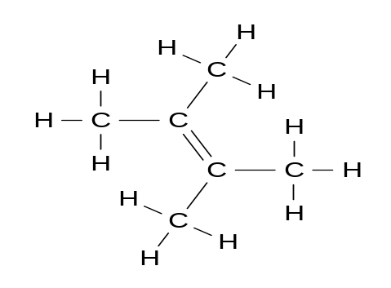
5. What is the correct IUPAC name for the following compound?

(a) 1,2-dimethyl cis-2-butene

(b) cis-2,3-dimethyl-1-butene

(c) 2,3-dimethyl-2-butene

(d) 2,3-methyl-1-butene

6. Which formula represents a molecule that can act as a monomer in an addition polymerisation reaction?

(a) CH₃CH₂CH₂CH₃
(b) H₂CC(CH₃)₂

(c) CH₃CH₂CH₃

(d) CH₃CH₂CH₂OH

7. Which of the following pairs of compounds would form propyl ethanoate when warmed with sulfuric acid?

(a) CH₃CH₂COOH and CH₃CH₂OH

- CH₃CH₂OH and CH₃CH₂CH₂OH
(c) CH₃COOH and CH₃CH₂CH₂OH
(d) CH₃OH and CH₃COOH
8. Which of the following molecules are planar?
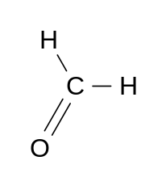
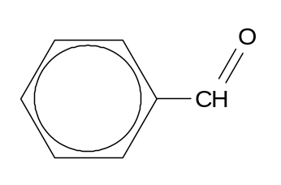
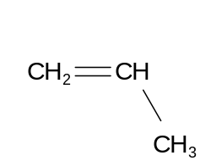
I II

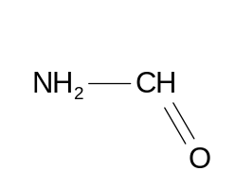
III IV

- I, II and IV only

- II and III only

- I and III only

- I and IV only

9. What is the concentration in parts per million of a solution of 0.0100 mol L⁻¹ NaOH_{(aq)} (molar mass (NaOH) = 40.00 g mol⁻¹ and density of solution = 1.00 g mL)

- 4.0 x 10² ppm

- 2.5 x 10³ ppm

- 4.0 x 10³ ppm

(d) 1.0 x 10⁻² ppm

10. Which of the following pairs of solutions would form a green precipitate when mixed?

- iron(III) nitrate and sodium hydroxide

- ammonium nitrate and chromium chloride

- copper(II) chloride and potassium nitrate

(d) nickel(II) sulfate and sodium carbonate

- Surfactants, or wetting agents, are used to remove grease and dirt from surfaces. Which of the following substances will not act as a surfactant?
(a) CH₃(CH₂)₁₆CO₂K
(b) CH₃(CH₂)₁₆CO₂H

(c) CH₃(CH₂)₁₂C₆H₄SO₃Na

(a) CH₃(CH₂)₁₄CO₂Na

12. The graph shows the distribution of kinetic energy of molecules in a fixed quantity of gas at 200ºC and 400ºC involved in a reaction that has an activation energy of 150 kJ mol⁻¹.

Number
of molecules 200ºC

400ºC

150 kJ mol⁻¹.
Kinetic Energy

Which of the following statements about the graph is false?

- The average kinetic energy of the particles is greater at 400ºC than at 200ºC.
(b) The total area under each graph should be equal.

(c) The reaction will not occur at 200ºC.

(d) Some molecules at 200ºC will have higher velocities than some at 400ºC.

13. Copper metal is dissolved in concentrated nitric acid to form a blue solution. When aqueous ammonia solution is added a pale blue precipitate forms initially which is replaced by a deep blue solution.The copper species goes through the following changes:

(a)

(b)

(c)
(d)

14. →

(a) 0.064 mol L⁻¹

(b) 0.150 mol L⁻¹

(c) 0.032 mol L⁻¹

(d) 0.015 mol L⁻¹

15. In the titration of hydrochloric acid (in burette) and sodium carbonate solution (in flask), which would be correct indicator to use and what would be the colour change at the end point?

Indicator Colour Change
(a) Phenolphthalein Pink to colourless
(b) Methyl orange Orange to yellow

(c) Methyl orange Yellow to red

(d) Phenolphthalein Colourless to pink

16. In which of the following compounds does chlorine have an oxidation state of +3 ?

(a) PCl₃

(b) Mg(ClO₂)₂
(c) HClO₃

(d) CH₃Cl
17. The following question relates to this process:

Which of the following statements is false?

(a) The water is acting as an acid.
(b) The hydroxide ion is the conjugate base of water.
(c) HSO₄⁻ is the conjugate acid of H₂SO₄.
(d) H₂SO₄ can donate a proton to OH⁻.

18. Which one of the following redox reactions will not occur spontaneously?

(a)

(b)

(c)

(d)

19. During the electrolysis of purified bauxite, what mass of pure aluminium would be deposited when 1000 moles of electrons are passed through the electrolytic cell? [ A_{r}(Al) = 27.0 ]

- 9.0 kg

- 3.0 kg

- 27.0 kg

- 81.0 kg

20. Which one of the following correctly arranges 1.0 mol L⁻¹ solutions of the substances in the order of increasing pH?

(a) H₃PO₄ H₂SO₄ CH₃COONa CH₃COOH NH₄CH₃COO

(b) H₂SO₄ H₃PO₄ CH₃COOH NH₄CH₃COO CH₃COONa
(c) H₂SO₄ H₃PO₄ CH₃COOH CH₃COONa NH₄CH₃COO

(d) H₃PO₄ H₂SO₄ NH₄CH₃COO CH₃COOH CH₃COONa

21. The discharging reactions occurring in a lead-acid accumulator cell are as follows:

Cathode:

Anode:

Which of the following statements regarding the discharging process are correct?

I The pH in the cell will increase.
II The mass of the anode will decrease.
III Lead is both oxidised and reduced in the process.
IV Hydrogen is reduced.

- I and III only

- II, III and IV only

- II and III only

- I and II only

- Which of these correctly show the trends in Electronegativity, First Ionisation Energy and Strength as a Reducing Agent as you go down the elements in group two of the periodic table from Be to Ra ?

Electronegativity First Ionisation Energy Reducing Strength

(a) Decreases Decreases Decreases

(b) Decreases Increases Increases
(c) Increases Decreases Decreases
(d) Decreases Decreases Increases

- The 2nd Ionisation energy of magnesium is the energy required per mole for the following process:

(a) 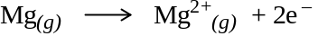
(b) 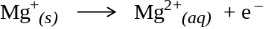
(c) 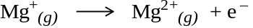
(d) 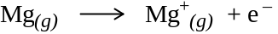

- An energy profile diagram for a chemical reaction is shown below.
300

Energy
(kJ mol L⁻¹)
250

200

150

Time
The reaction is:

(a) Exothermic with an activation energy of +100 kJ mol L⁻¹

- Endothermic with an activation energy of +150 kJ mol L⁻¹

(c) Exothermic with an of enthalpy change +50 kJ mol L⁻¹

(d) Endothermic with an enthalpy change of +200 kJ mol L⁻¹

25. In which of the following substances would hydrogen bonding occur?

I HF II NH₃ III H₂ IV HCl

(a) I and III only

(b) II, III and IV only

(c) II and III only

(d) I and II only

26. Graphite conducts electricity because:

- It is a covalent network solid.

- It contains positive ions.

- It has a layer structure.

- It contains delocalised electrons.

27. The following statements are about atomic orbitals:

I Each orbital can accommodate a maximum of 2 electrons.

II Electrons in the 3s orbital have less energy than electrons in a 2p orbital.

III There are 3 p-orbitals in each principal energy level.

Which statements are false?

(a) I only

(b) I, II and III

(c) II and III only

(d) II only

28. Which of the following structures is an isomer of 2-chloro-3-methyl-1-pentene?

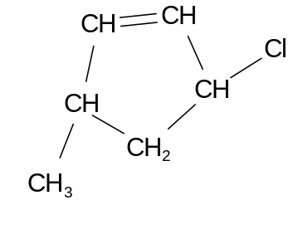
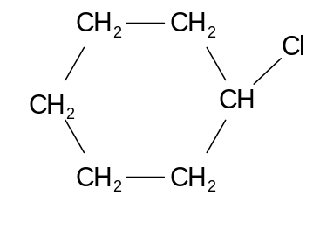
A B

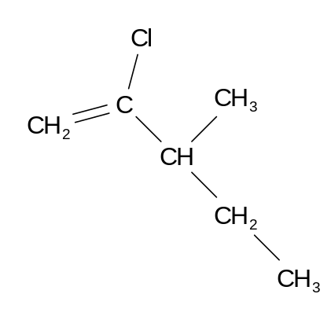

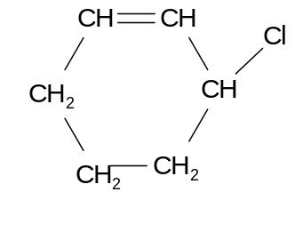
C D

(a) A
(b) B
(c) C
(d) D
29. The atomic number of manganese is 25. The electron configuration of the Mn⁴⁺ ion could be:

(a) 1s²2s²2p⁶3s²3p⁶3d³
(b) 1s²2s²2p⁶3s²3p⁶4s²3d³

(c) 1s²2s²2p⁶3s²3p⁶4s²3d⁹

(d) 1s²2s²2p⁶3s²3p⁶3d⁵

- The correct equation for the reaction of ammonia solution with silver(I) oxide is as follows:

(a)
(b)

(c)

(d)

END OF PART 1

PART 2 (70 marks = 35% of paper)

Answer ALL questions in Part 2 in the spaces provided below.
_______________________________________________________________________________

- Write equations for any reactions that occur in the following procedures. If no reaction occurs write 'no reaction'

In each case describe in full what you would observe, including any
• colours
• odours
• precipitates (give the colour)
• gases evolved (give the colour or describe as colourless).
If no change is observed, you should state this.

(a) 5 mol L⁻¹ sodium hydroxide solution is added to zinc hydroxide and warmed.

Equation _________________________________________________________________

Observation ______________________________________________________________

_________________________________________________________________________
[3 marks]

- Dilute sodium hydroxide is added dropwise to copper (II) nitrate solution.

Equation _________________________________________________________________

Observation ______________________________________________________________

_________________________________________________________________________
[3 marks]

(c) Sodium metal is added to ethanol.
Equation _________________________________________________________________

Observation ______________________________________________________________

_________________________________________________________________________
[3 marks]

(d) Hydrogen peroxide solution is added to sodium bromide solution..
Equation _________________________________________________________________

Observation ______________________________________________________________

_________________________________________________________________________
[3 marks]

- Complete the table below by choosing one of the aqueous solutions A-I from the following list that match the description. (You can use each substance more than once)

A 2.0 mol L⁻¹ HCl _{(aq)}
B 1.0 mol L⁻¹ NH₄Cl _{(aq)}
C 1.0 mol L⁻¹ Au(NO₃)_{3(aq)}
D 0.1 mol L⁻¹ H₂C₂O_{4 (aq)}
E 1.0 mol L⁻¹ Na₂CO_{3(aq)}
F 0.1 mol L⁻¹ Br_{2(aq)}
G 0.01mol L⁻¹ HCl_{(aq)}
H 0.02 mol L⁻¹ NaOH_{(aq)}
I 1.0 mol L⁻¹ Fe(NO₃)₂

Description | Solution  (state letter)
Will have a pH of 2.0.
Will decolourise when added to C₂H_{2.}
Can oxidise bromide ions to bromine.
Will form a precipitate when added to a solution of BaCl₂.
Will become a red/brown colour when left in air.
Can reduce Sn²⁺ to tin metal but not Mg²⁺ to magnesium metal.
Contains a salt of a weak acid.
Will go pink when a few drops of phenolphthalein are added.

[8 marks]

- Calculate the pH of a solution containing 25.0 mL of 2.0 mol L⁻¹ sodium hydroxide and 49.5 mL of 1.0 mol L⁻¹ hydrochloric acid.

[4 marks]

4. The overall reaction occurring in a dry cell can be shown as follows:

- Explain the role of zinc in the cell.

[2 marks]
- Explain the role of the ammonium ions in the cell.

[2 marks]

5. The following diagram shows the final stage in the extraction of Gold.

+ -

Stainless steel anode Steel wool cathode

1.0 mol L⁻¹ [Au(CN)₂]⁻ /OH⁻_{(aq)}

(a) Using half equations from your data sheet, complete the following table for this process:

Anode half-equation:
Cathode half-equation:
Overall equation:

[3 marks]

(b) Calculate the minimum voltage required for this process to occur.

[1 marks]
(c) Explain why stainless steel is required for the anode.

[2 marks]
6. (a) Write the equilibrium constant expression for the following reaction.

[2 marks]
(b) With reference to the following equilibrium:

and the system in (a), explain why a solution of dichromate ions becomes a lighter orange when alkali is added.

[3 marks]
- This question is about how imposed changes affect the following reaction at equilibrium.

Complete the table by predicting the initial effect on the rate of the forward and reverse reactions and the position of equilibrium once it has been re-established.

Imposed change | Forward reaction  Faster, slower or no change | Reverse reaction  Faster, slower or no change | Effect on equilibrium position  to right, to left,  or no change
Reduce temperature
Reduce pressure
Increase surface area of the CaCO₃
[9 marks]
8. For each species listed in the table below draw an electron dot diagram to show the bonding, sketch the shape, and state the polarity of the species.

Species | Electron dot diagram | Shape  (sketch) | Polarity  (polar or  non-polar)
BF₃
HCO₃⁻

[6 marks]
9. Explain, using a diagram and equations, why the corrosion of iron on the hull of a boat can be reduced by the attachment of pieces of zinc metal at positions along the hull.

[4 marks]

10. The two compounds below were reacted together in the presence of concentrated sulphuric acid.

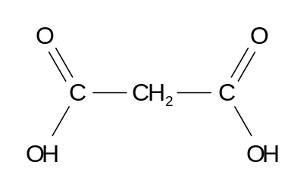
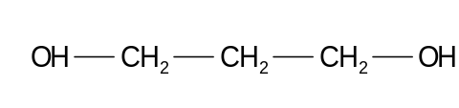
A B

(a) Draw the structure of the product.

[2 marks]
(b) Name the other product in the reaction.

[1 marks]
(c) Suggest a reason for the presence of the sulphuric acid.

[1 mark]
(d) What reagents could be used to convert A into B?

[2 marks]
11. Explain how you could distinguish between the following pairs of compounds using chemical tests.

 | Compounds | Description of Test | Observations
(a) | PbCl_{2(s)} |  | with PbCl_{2(s)}
(a) | KCl_{(s)} |  | with KCl_{(s)}
(b) | CH₃CO₂C₂H₅ |  | with CH₃CO₂C₂H₅
(b) | C₃H₇CO₂H |  | with C₃H₇CO₂H
(c) | 1-pentanol |  | with 1-pentanol
(c) | 2-ethyl-2-propanol |  | with 2-ethyl-2-propanol

[6 marks]
END OF PART 2

THIS PAGE HAS BEEN INTENTIONALLY LEFT BLANK
PART 3 (50 marks = 25% of the paper)

Answer ALL questions in Part 3. The calculations are to be set out in detail in this Question/Answer Booklet. Marks will be allocated for correct answers and clear setting out, even if you cannot complete the problem. When questions are divided into sections, clearly distinguish each section using (a), (b) and so on. Express your final numerical answers to three (3) significant figures where appropriate, and provide units where applicable. Information which may be necessary for solving the problems is located on the separate Chemistry Data Sheet. Show clear reasoning: if you don’t, you will lose marks.
________________________________________________________________________________

1. Titratable acidity is a measure of the concentration of all available hydrogen ions that can be neutralised by a base. It is an important measurement in the analysis of many foods including milk and wine.

In the wine industry titratable acidity is recorded as: g(Tartaric Acid)/100 ml sample.
Tartaric acid has the molecular formula of C₄H₆O₆ and is a diprotic acid.
The following experiment was carried out:

Procedure:
Pipette 5.00 mL of wine into flask. Add approximately 100 mL distilled water and a few drops of phenolphthalein. Titrate against 0.100 M NaOH.

Results
Burette readings (mL) | Titrations
Burette readings (mL) | 1 | 2 | 3 | 4
Final volume | 6.50 | 11.40 | 17.25 | 23.25
Initial volume | 0.00 | 5.50 | 11.30 | 17.25
Titre

- Complete the table and calculate the titration volume.
[2 marks]
(b) Calculate the concentration of available hydrogen ions in the original sample of wine in molL^{-1.}.
[3 marks]
(c) Assuming this acidity was caused solely by tartaric acid, convert this to the concentration as grams of tartaric acid per 100 mL sample of wine.
[3 marks]
(d) Suggest a difficulty that may arise if red wine is used in this experiment.
[1 marks]
________________________________________________________________________________________

________________________________________________________________________________________

________________________________________________________________________________________

________________________________________________________________________________________

________________________________________________________________________________________

________________________________________________________________________________________

________________________________________________________________________________________

________________________________________________________________________________________

________________________________________________________________________________________

________________________________________________________________________________________

________________________________________________________________________________________

________________________________________________________________________________________

________________________________________________________________________________________

________________________________________________________________________________________

________________________________________________________________________________________

________________________________________________________________________________________

________________________________________________________________________________________

________________________________________________________________________________________

________________________________________________________________________________________

________________________________________________________________________________________

________________________________________________________________________________________

________________________________________________________________________________________

________________________________________________________________________________________

________________________________________________________________________________________

________________________________________________________________________________________

________________________________________________________________________________________

________________________________________________________________________________________

________________________________________________________________________________________

________________________________________________________________________________________

________________________________________________________________________________________

________________________________________________________________________________________

________________________________________________________________________________________
2. An Organic Ester underwent hydrolysis to produce a monoprotic carboxylic Acid X and a secondary alcohol Y that has an empirical formula of C₄H₁₀O.

A 17.50 g sample of pure X, when combusted produced 44.15g of carbon dioxide and 7.750g of water.

Y was oxidised with potassium dichromate as follows:

44.88mL of 0.500 molL⁻¹ potassium dichromate was required to oxidise 4.99g of Y.

- Calculate the empirical formula of X
[4 marks]
(b) Calculate the Molar Mass of Y from the reaction with potassium dichromate
[3 marks]
(c) Draw possible structures of X and Y
[2 marks]
(d) Draw and name the original Ester.
[2 marks]

________________________________________________________________________________________

________________________________________________________________________________________

________________________________________________________________________________________

________________________________________________________________________________________

________________________________________________________________________________________

________________________________________________________________________________________

________________________________________________________________________________________

________________________________________________________________________________________

________________________________________________________________________________________

________________________________________________________________________________________

________________________________________________________________________________________

________________________________________________________________________________________

________________________________________________________________________________________

________________________________________________________________________________________

________________________________________________________________________________________

________________________________________________________________________________________

________________________________________________________________________________________

________________________________________________________________________________________

________________________________________________________________________________________

________________________________________________________________________________________

________________________________________________________________________________________

________________________________________________________________________________________

________________________________________________________________________________________

________________________________________________________________________________________

________________________________________________________________________________________

________________________________________________________________________________________

________________________________________________________________________________________

________________________________________________________________________________________

________________________________________________________________________________________

________________________________________________________________________________________

3. Chromium plating is often used to improve the appearance and corrosion protection of metallic objects. Inert electrodes are used to electrolyse an acidified solution of sodium dichromate and the equations involved are as follows:

Cathode:

Anode:

Overall:
Because chromium metal is not used as the anode, chromium salts have to be added periodically to the electrolytic cell.

A steel object is made the cathode, and a current of 2.50 Amps is passed through a tank containing 5.00 L of 1.00 mol L⁻¹ sodium dichromate. The original pH of the solution is 2.00.

(a) For how many minutes will the current need to flow to deposit 2.50 g of chromium metal on the steel object?
[4 marks]
(b) What would be the pH of the solution after this time.(assume volume is maintained at 5.00 Litres)
[4 marks]
(c) What mass of solid sodium dichromate would be needed to be added to the solution to replace the used dichromate ions?
[3 marks]
(d) Suggest a reason why chromium is not used as the anode in the process.
[1 marks]

________________________________________________________________________________________

________________________________________________________________________________________

________________________________________________________________________________________

________________________________________________________________________________________

________________________________________________________________________________________

________________________________________________________________________________________

________________________________________________________________________________________

________________________________________________________________________________________

________________________________________________________________________________________

________________________________________________________________________________________

________________________________________________________________________________________

________________________________________________________________________________________

________________________________________________________________________________________

________________________________________________________________________________________

________________________________________________________________________________________

________________________________________________________________________________________

________________________________________________________________________________________

________________________________________________________________________________________

________________________________________________________________________________________

________________________________________________________________________________________

________________________________________________________________________________________

________________________________________________________________________________________

________________________________________________________________________________________

________________________________________________________________________________________

________________________________________________________________________________________

________________________________________________________________________________________

________________________________________________________________________________________

________________________________________________________________________________________

________________________________________________________________________________________

________________________________________________________________________________________

________________________________________________________________________________________

________________________________________________________________________________________

________________________________________________________________________________________

________________________________________________________________________________________

________________________________________________________________________________________

________________________________________________________________________________________

________________________________________________________________________________________

________________________________________________________________________________________

________________________________________________________________________________________

________________________________________________________________________________________

________________________________________________________________________________________

________________________________________________________________________________________
4. A sample of hydrated iron(II) sulfate FeSO₄.xH₂O was analysed to calculate the value of x.

A solution of potassium permanganate was standardised by reacting it with 0.200 mol L⁻¹ oxalic acid (H₂C₂O₄). 29.07 mL of the oxalic acid reacted with 22.15 mL of the potassium permanganate.

13.45 g of the hydrated solid was dissolved in approximately 40 mL of distilled water and the solution made up to 250 mL. 20 mL samples of this solution where titrated against
the standardised potassium permanganate solution and 7.37 mL was required for complete reaction.

The relevant half equations are:

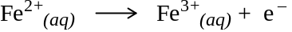

(a) Write equation for the standardisation reaction and calculate the concentration of the standardised potassium permanganate solution.
[4 marks]
(b) Write equation for the titration reaction and calculate the number of moles of Fe²⁺ ions in the original solid sample.
[4 marks]
(c) Calculate the value of x.
[4 marks]

________________________________________________________________________________________

________________________________________________________________________________________

________________________________________________________________________________________

________________________________________________________________________________________

________________________________________________________________________________________

________________________________________________________________________________________

________________________________________________________________________________________

________________________________________________________________________________________

________________________________________________________________________________________

________________________________________________________________________________________

________________________________________________________________________________________

________________________________________________________________________________________

________________________________________________________________________________________

________________________________________________________________________________________

________________________________________________________________________________________

________________________________________________________________________________________

________________________________________________________________________________________

________________________________________________________________________________________

________________________________________________________________________________________

________________________________________________________________________________________

________________________________________________________________________________________

________________________________________________________________________________________

________________________________________________________________________________________

________________________________________________________________________________________

________________________________________________________________________________________

________________________________________________________________________________________

________________________________________________________________________________________

________________________________________________________________________________________

________________________________________________________________________________________

________________________________________________________________________________________

________________________________________________________________________________________

________________________________________________________________________________________

________________________________________________________________________________________

________________________________________________________________________________________

________________________________________________________________________________________

________________________________________________________________________________________

________________________________________________________________________________________

________________________________________________________________________________________

________________________________________________________________________________________

________________________________________________________________________________________

________________________________________________________________________________________

________________________________________________________________________________________
5. Standard unleaded petrol has an Octane Number of 92 which means it burns in a similar way to a test sample of 92% (by mass) 2,2,4-trimethylpentane (C₈H₁₈) and 8% heptane (C₇H₁₆).

45.0g of this test sample was completely combusted in 130 L oxygen at 25ºC and 100 kPa.
The equations for the combustion's are as follows:

- Calculate the masses of each compound in the test sample.
[1 mark]
(b) Calculate the volume of oxygen (at S.T.P.) remaining after the complete combustion.
[5 marks]

________________________________________________________________________________________

________________________________________________________________________________________

________________________________________________________________________________________

________________________________________________________________________________________

________________________________________________________________________________________

________________________________________________________________________________________

________________________________________________________________________________________

________________________________________________________________________________________

________________________________________________________________________________________

________________________________________________________________________________________

________________________________________________________________________________________

________________________________________________________________________________________

________________________________________________________________________________________

________________________________________________________________________________________

________________________________________________________________________________________

________________________________________________________________________________________

________________________________________________________________________________________

________________________________________________________________________________________

________________________________________________________________________________________

________________________________________________________________________________________
END OF PART 3
PART 4 (20 marks = 10% of paper)

Answer ONE of the following extended answer questions. Where applicable use equations, diagrams and illustrative examples of the chemistry you are describing.

Marks are awarded principally for the relevant chemical content of your answer, and also for coherence and clarity of expression. Your answer should be presented in about 1½ to 2 pages on the lined paper after the questions.
_________________________________________________________________________________

EITHER:

- The following is an outline of the production of Aluminium from Bauxite.
Bauxite

Heated
Impure Aluminium Hydroxide Al(OH)₃

Hot NaOH_{(aq)} Solution

Filtered
Insoluble Impurities Fe₂O₃ SiO₂
Aluminate [Al(OH)₄]⁻Solution

Cooled and Seeded
with Al(OH)_{3(s)}
Solid Aluminium Oxide Al₂O₃

Add cryolite (NaAlF₆)
and Heated

Electrolytic Cell

Cathode Anode
Solid Aluminium
Carbon Dioxide

Using one example from this process and one example of your choice, explain the meaning of each of the following terms. Discuss clearly how the concepts are used both in the production of Aluminium and in your chosen example.

- Amphoteric Nature
- Complex Ion
- Precipitation
- Electrolytic Reduction

OR:

2. The following is a summary of the Production of Nitric Acid.

Production of Nitric Acid
The first stage produces nitric acid which has concentrations ranging from 30% to 70%. This is then converted into high-strength nitric acid that contains more than 90 % nitric acid.

1. Ammonia Oxidation
A 1:9 ammonia/air mixture is oxidised at a temperature of 1380 ºC to 1470 ºC as it passes through a catalytic convertor, according to the following reaction:

The most commonly used catalyst is made of 90% platinum and 10% rhodium gauze constructed from squares of fine wire. Under these conditions the oxidation of ammonia to nitric oxide (NO) proceeds in an exothermic reaction with a range of 93-98% yield. Higher catalyst temperatures increase NO production.

2. Nitric Oxide Oxidation
The nitric oxide formed during the ammonia oxidation must be oxidised. The gases are cooled to 100 ºC or less at pressures up to 8 atm. The nitric oxide reacts non-catalytically with residual oxygen to form nitrogen dioxide (NO₂)

This slow, homogeneous reaction is highly temperature and pressure dependent. Operating at low temperatures and high pressures promotes maximum production of NO₂ within a minimum reaction time.

3. Absorption
An exothermic reaction occurs between NO₂ and steam as follows:

A secondary air stream is introduced into the column to re-oxidise the NO that is formed in the Reaction. This secondary air also removes NO from the product acid. The acid concentration can vary from 30% to 70% nitric acid.

4. High-Strength Nitric Acid Production
Concentrated nitric acid can be obtained by concentrating the weak nitric acid using extractive distillation. Normal distillation cannot be used due to strong intermolecular attractions between Nitric Acid and Water. The distillation must be carried out in the presence of a dehydrating agent. Concentrated sulfuric acid is most commonly used for this purpose. Concentrated nitric acid leaves the top of the column as 99% vapour which is then condensed.
Explain the Chemistry behind the design of the process at each stage. You can use the concepts of Stoichiometry, Rate of Reaction, Dynamic Equilibrium and Intermolecular Bonding. Include how the process maximises the final yield of Nitric Acid.

END OF QUESTIONS

________________________________________________________________________________________

________________________________________________________________________________________

________________________________________________________________________________________

________________________________________________________________________________________

________________________________________________________________________________________

________________________________________________________________________________________

________________________________________________________________________________________

________________________________________________________________________________________

________________________________________________________________________________________

________________________________________________________________________________________

________________________________________________________________________________________

________________________________________________________________________________________

________________________________________________________________________________________

________________________________________________________________________________________

________________________________________________________________________________________

________________________________________________________________________________________

________________________________________________________________________________________

________________________________________________________________________________________

________________________________________________________________________________________

________________________________________________________________________________________

________________________________________________________________________________________

________________________________________________________________________________________

________________________________________________________________________________________

________________________________________________________________________________________

________________________________________________________________________________________

________________________________________________________________________________________

________________________________________________________________________________________

________________________________________________________________________________________

________________________________________________________________________________________

________________________________________________________________________________________

________________________________________________________________________________________

________________________________________________________________________________________

________________________________________________________________________________________

________________________________________________________________________________________

________________________________________________________________________________________

________________________________________________________________________________________

________________________________________________________________________________________

________________________________________________________________________________________

________________________________________________________________________________________

________________________________________________________________________________________

________________________________________________________________________________________

________________________________________________________________________________________

________________________________________________________________________________________

________________________________________________________________________________________

________________________________________________________________________________________

________________________________________________________________________________________

________________________________________________________________________________________

________________________________________________________________________________________

________________________________________________________________________________________

________________________________________________________________________________________

________________________________________________________________________________________

________________________________________________________________________________________

________________________________________________________________________________________

________________________________________________________________________________________

________________________________________________________________________________________

________________________________________________________________________________________

________________________________________________________________________________________

________________________________________________________________________________________

________________________________________________________________________________________

________________________________________________________________________________________

________________________________________________________________________________________

________________________________________________________________________________________

________________________________________________________________________________________

________________________________________________________________________________________

________________________________________________________________________________________

________________________________________________________________________________________

________________________________________________________________________________________

________________________________________________________________________________________

________________________________________________________________________________________

________________________________________________________________________________________

________________________________________________________________________________________

________________________________________________________________________________________

________________________________________________________________________________________

________________________________________________________________________________________

________________________________________________________________________________________

________________________________________________________________________________________

________________________________________________________________________________________

________________________________________________________________________________________

________________________________________________________________________________________

________________________________________________________________________________________

________________________________________________________________________________________

________________________________________________________________________________________

________________________________________________________________________________________

________________________________________________________________________________________

________________________________________________________________________________________

________________________________________________________________________________________

________________________________________________________________________________________

________________________________________________________________________________________

________________________________________________________________________________________

________________________________________________________________________________________

________________________________________________________________________________________

________________________________________________________________________________________

________________________________________________________________________________________

________________________________________________________________________________________

________________________________________________________________________________________

________________________________________________________________________________________

________________________________________________________________________________________

________________________________________________________________________________________

________________________________________________________________________________________

________________________________________________________________________________________

________________________________________________________________________________________

________________________________________________________________________________________

________________________________________________________________________________________

________________________________________________________________________________________

________________________________________________________________________________________

________________________________________________________________________________________

________________________________________________________________________________________

________________________________________________________________________________________

________________________________________________________________________________________

________________________________________________________________________________________

________________________________________________________________________________________

END OF EXAM

